1

Table - Agents

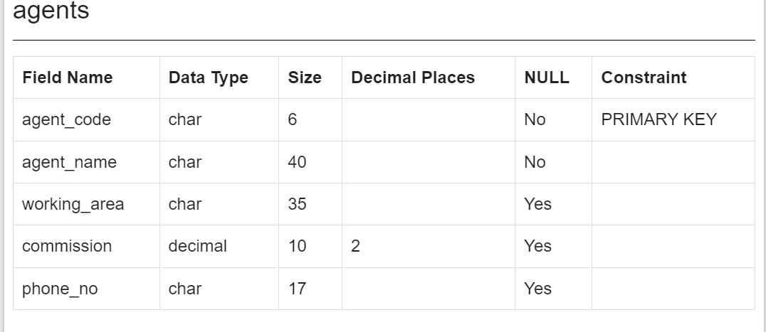

Table – Customer1

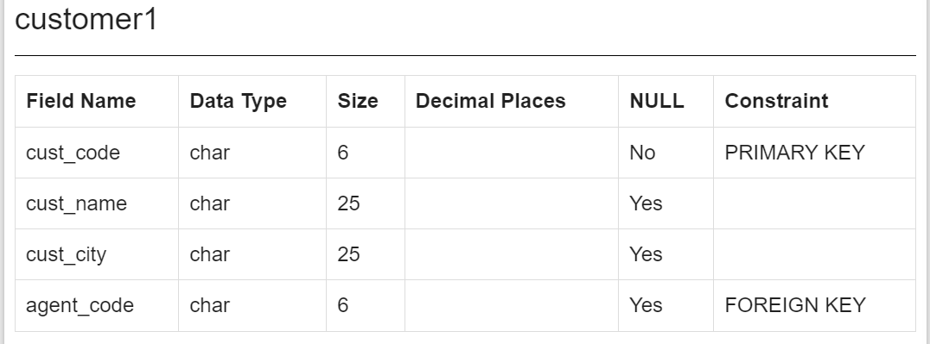

Data for Agent Table:

|  |  |  |  |  |  |
| --- | --- | --- | --- | --- | --- |
| AGENT_CODE | AGENT_NAME | WORKING_AREA | COMMISSION | PHONE_NO | COUNTRY |
| A001 | Subbarao | Bangalore | 0.14 | 077-12346674 |  |
| A002 | Mukesh | Mumbai | 0.11 | 029-12358964 |  |
| A003 | Alex | London | 0.13 | 075-12458969 |  |
| A004 | Ivan | Torento | 0.15 | 008-22544166 |  |
| A005 | Anderson | Brisban | 0.13 | 045-21447739 |  |
| A006 | McDen | London | 0.15 | 078-22255588 |  |
| A007 | Ramasundar | Bangalore | 0.15 | 077-25814763 |  |
| A008 | Alford | New York | 0.12 | 044-25874365 |  |
| A009 | Benjamin | Hampshair | 0.11 | 008-22536178 |  |
| A010 | Santakumar | Chennai | 0.14 | 007-22388644 |  |
| A011 | Ravi Kumar | Bangalore | 0.15 | 077-45625874 |  |
| A012 | Lucida | San Jose | 0.12 | 044-52981425 |  |

Data for Customer Table:

|  |  |  |  |  |  |  |  |  |  |  |  |
| --- | --- | --- | --- | --- | --- | --- | --- | --- | --- | --- | --- |
| C00001 | Micheal | New York | New York | USA | 2 | 3000 | 5000 | 2000 | 6000 | CCCCCCC | A008 |
| C00002 | Bolt | New York | New York | USA | 3 | 5000 | 7000 | 9000 | 3000 | DDNRDRH | A008 |
| C00003 | Martin | Torento | Torento | Canada | 2 | 8000 | 7000 | 7000 | 8000 | MJYURFD | A004 |
| C00004 | Winston | Brisban | Brisban | Australia | 1 | 5000 | 8000 | 7000 | 6000 | AAAAAAA | A005 |
| C00005 | Sasikant | Mumbai | Mumbai | India | 1 | 7000 | 11000 | 7000 | 11000 | 147-25896312 | A002 |
| C00006 | Shilton | Torento | Torento | Canada | 1 | 10000 | 7000 | 6000 | 11000 | DDDDDDD | A004 |
| C00007 | Ramanathan | Chennai | Chennai | India | 1 | 7000 | 11000 | 9000 | 9000 | GHRDWSD | A010 |
| C00008 | Karolina | Torento | Torento | Canada | 1 | 7000 | 7000 | 9000 | 5000 | HJKORED | A004 |
| C00009 | Ramesh | Mumbai | Mumbai | India | 3 | 8000 | 7000 | 3000 | 12000 | Phone No | A002 |
| C00010 | Charles | Hampshair | Hampshair | UK | 3 | 6000 | 4000 | 5000 | 5000 | MMMMMMM | A009 |
| C00011 | Sundariya | Chennai | Chennai | India | 3 | 7000 | 11000 | 7000 | 11000 | PPHGRTS | A010 |
| C00012 | Steven | San Jose | San Jose | USA | 1 | 5000 | 7000 | 9000 | 3000 | KRFYGJK | A012 |
| C00013 | Holmes | London | London | UK | 2 | 6000 | 5000 | 7000 | 4000 | BBBBBBB | A003 |
| C00014 | Rangarappa | Bangalore | Bangalore | India | 2 | 8000 | 11000 | 7000 | 12000 | AAAATGF | A001 |
| C00015 | Stuart | London | London | UK | 1 | 6000 | 8000 | 3000 | 11000 | GFSGERS | A003 |
| C00016 | Venkatpati | Bangalore | Bangalore | India | 2 | 8000 | 11000 | 7000 | 12000 | JRTVFDD | A007 |
| C00017 | Srinivas | Bangalore | Bangalore | India | 2 | 8000 | 4000 | 3000 | 9000 | AAAAAAB | A007 |
| C00018 | Fleming | Brisban | Brisban | Australia | 2 | 7000 | 7000 | 9000 | 5000 | NHBGVFC | A005 |
| C00019 | Yearannaidu | Chennai | Chennai | India | 1 | 8000 | 7000 | 7000 | 8000 | ZZZZBFV | A010 |
| C00020 | Albert | New York | New York | USA | 3 | 5000 | 7000 | 6000 | 6000 | BBBBSBB | A008 |
| C00021 | Jacks | Brisban | Brisban | Australia | 1 | 7000 | 7000 | 7000 | 7000 | WERTGDF | A005 |
| C00022 | Avinash | Mumbai | Mumbai | India | 2 | 7000 | 11000 | 9000 | 9000 | 113-12345678 | A002 |
| C00023 | Karl | London | London | UK | 0 | 4000 | 6000 | 7000 | 3000 | AAAABAA | A006 |
| C00024 | Cook | London | London | UK | 2 | 4000 | 9000 | 7000 | 6000 | FSDDSDF | A006 |
| C00025 | Ravindran | Bangalore | Bangalore | India | 2 | 5000 | 7000 | 4000 | 8000 | AVAVAVA | A011 |

Tasks-

1. Create the two tables above
2. Insert the Data using insert command
3. Create relationship (Foreign Key) between this two tables by identifying the common field.
4. Try to insert/Update/Delete data which is being referenced in either tables.